Title: "HSX Handheld Nut Runner - Pioneering Smart Tools for Modern Manufacturing"

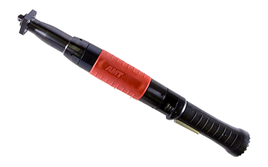  
Introducing the [HSX series](https://absgroup.in/handheld-nutrunner), the latest evolution of handheld nut runners in our lineup. Building on the success of the HCX series, the HSX tools bring forth a new era of innovation, featuring digital signal transmission, a sleek design, and compatibility with mobile devices for enhanced control and monitoring.

**Digital Advancements for a Streamlined Experience:**

[The HSX series](https://absgroup.in/handheld-nutrunner) marks a significant leap forward with the implementation of fully digital signal transmission between the [nut runner](https://absgroup.in/handheld-nutrunner) and [control](https://absgroup.in/products-category/controller). This breakthrough not only results in a lighter and more compact tool cable but also contributes to an overall enhanced ergonomic design.

**Revolutionizing Control with New Generation Technology:**

Accompanying the [HSX handheld nut runners](https://absgroup.in/handheld-nutrunner) is a cutting-edge control generation, purpose-built for efficiency and adaptability. This innovative control system opens up new possibilities by allowing programming and monitoring of the tool using mobile devices such as tablets or smartphones.

**Sleek and Ergonomic Design:**

The HSX series places a strong emphasis on user comfort and usability. The improved ergonomic design ensures a more comfortable grip, reducing operator fatigue during prolonged use. The thinner and lighter tool cable further adds to the overall ease of handling.

**Mobile Integration for Unprecedented Control:**

With the new control generation, users can now program and monitor the [HSX handheld nut runners](https://absgroup.in/handheld-nutrunner) using their mobile devices. This mobile integration not only enhances convenience but also facilitates real-time monitoring and adjustments, giving operators greater control over the assembly processes.

**Efficiency Redefined:**

The HSX series doesn't just represent a tool; it signifies a paradigm shift in the way nut runners contribute to manufacturing efficiency. The combination of digital transmission, ergonomic design, and mobile integration creates a tool that's not just smarter but also more adaptable to the dynamic needs of modern manufacturing.

**Conclusion:**

In the ever-evolving landscape of manufacturing, [the HSX Handheld Nut Runner](https://absgroup.in/handheld-nutrunner) stands as a symbol of progress. Embrace the future of smart tools with HSX, where innovation meets efficiency, and precision is at your fingertips. Elevate your assembly processes with a tool that not only keeps up with the times but defines them.